Jimena Hogrebe Rodríguez

**Del Moral, Enrique (1906-1987)**

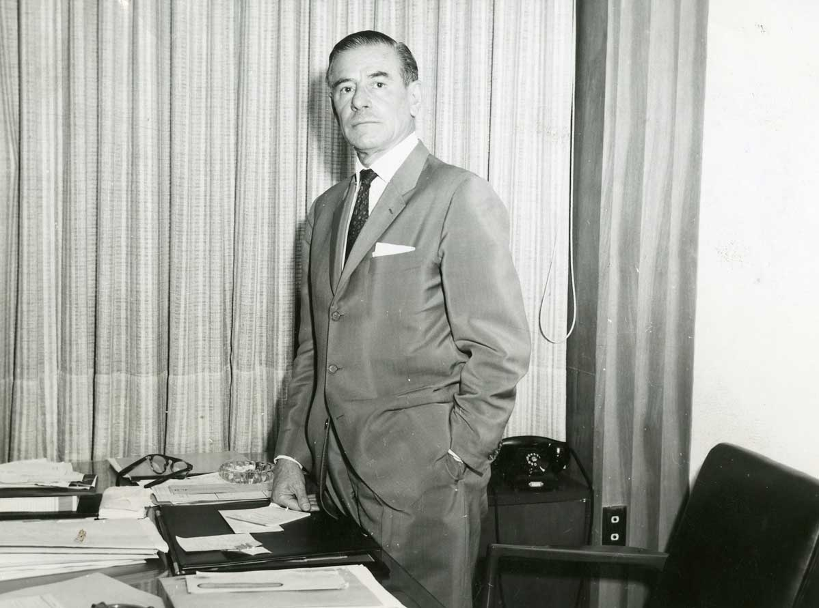

Enrique del Moral

Copyright: Fototeca INEHRM <http://www.inehrm.gob.mx/imagenes/construnam/07.jpg>

Born in Irapuato, Guanajuato, Mexican architect Enrique del Moral Domínguez (1906-1987) moved to Mexico City as a child. There, he studied architecture (1923-1928) in the National School of Beaux Arts with Juan O’Gorman and José Villagrán García, his teacher and mentor. Educated in the post-revolution years, he was interested in the construction of an architecture corresponding to Mexican identity – which had been in a continuous struggle between the new and the old – and building for the needs of the people. Del Moral was part of the generation which found in functionalism a way to respond to their historical moment. Even though, he intended to integrate the international modern architecture with Mexican culture and geography, what he called the global and the local.

His professional experience after graduating began in 1936 with a housing complex in Irapuato – in partnership with Marcial Gutiérrez Camarena – where pure forms and regional expressions where incorporated. After this, he continued designing housing projects, a hospital and education buildings. In 1946 he developed a rural primary school in Casacuarán, a modern building constructed with vernacular methods: crude timber and brick. Del Moral designed his own house in Tacubaya, Mexico City (1948-1949), where he explored the combination of a modern structure, traditional materials and various textures. He also examined the separation of public and private areas and their connection with the exterior, the first ones around the garden and the latter towards the *pati*o – a reinterpretation of Mexican typology.

Del Moral became a professor at the National School of Architecture in 1934 and evolved into director some years later (1944-1949). During this period he examined ideas about artistic changes, modernism and Mexican architecture in a series of essays. As a director he got the opportunity to coordinate and design, with Mario Pani, the master plan for the University City (UNAM) and the Rectory Tower (1947-1952). The campus was a functionalist complex in combination with the local topography and references to pre-Columbian configurations; and the Rectory Tower was a modern structure mixed with Mexican materials and murals by David Alfaro Siqueiros, where Del Moral explored his interest in plastic integration.

From the 50’s on, Del Moral continued his work developing private and public projects, being La Merced Market in Mexico City (1956-1957) one of the latter. There he proposed a low-cost concrete and brick vaulting solution with an inventive expression. He also developed a series of hospitals and institutional buildings in this period, as well as housing. The work by Enrique del Moral shows the transition from post-revolutionary Mexico to a modern country.

**List of works**

1944 Yturbe House, Acapulco, Mexico

1950 Secretary of Hydraulic Resources, Mexico City (with Mario Pani)

1952 Airport, Acapulco, Mexico (with Mario Pani)

1962-1963 Treasury of the Federal District, Mexico City

1962-1963 Nurses School and Centre for Medical Research, ISSTE, Mexico City

**References and further reading**

Del Moral, E. (1983) *El hombre y la arquitectura: Ensayos y testimonios*, Mexico City: UNAM.

Curtis, W. (1997) ‘The General and the Local. Enrique del Moral’s Own House’ in ed. Burian, E. R. *Modernity and the Architecture of Mexico*, Austin: University of Texas Press.

Noelle, L. (2004), *Enrique del Moral. Vida y obra*, Mexico: UNAM.

**Visual material:**

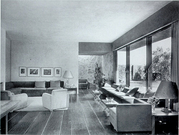

Del Moral House, Mexico City, 1948-1949

Copyright: Archive of Louise Noelle Merles <http://www.conaculta.gob.mx/academiadeartes/miem1.html>

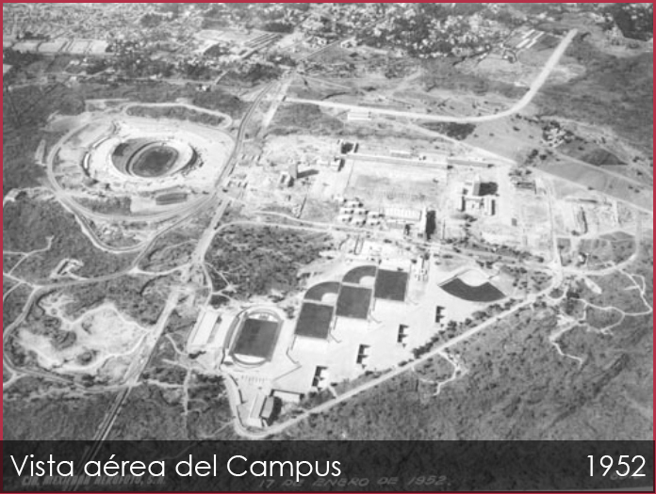

University City Campus, Mexico City, 1947-1952

Copyright: Historical Archive UNAM <http://www.patrimoniomundial.unam.mx/contenidoEstatico/galeria/verGaleria/22/galeria-historica>

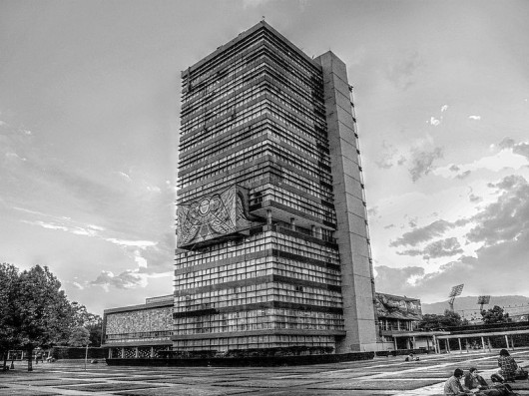

Rectory Tower, Mexico City,1947-1952

Copyright: INEHRM, UNAM <http://www.archdaily.mx/211423/>

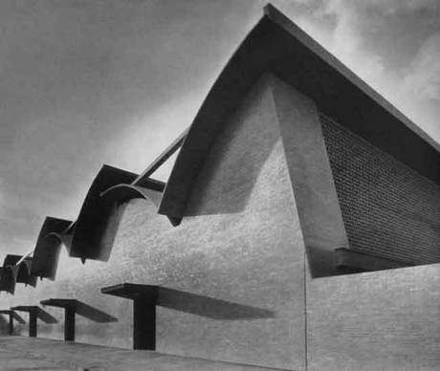

La Merced Market, Mexico City,1956-1957

Copyright: UNAM

<http://www.letraslibres.com/revista/letrillas/enrique-del-moral-1906-1987>

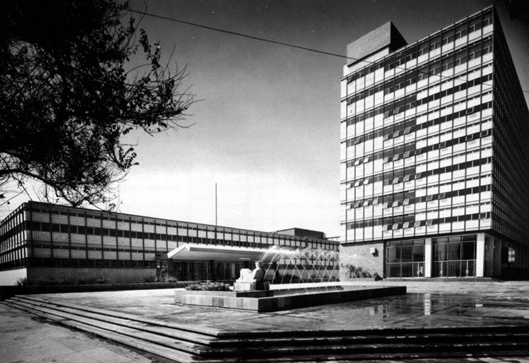

Treasury of the Federal District, Mexico City, 1962-1963

Copyright: UNAM

<http://www.arquine.com/wp-content/uploads/2013/01/tesoreria.jpg>